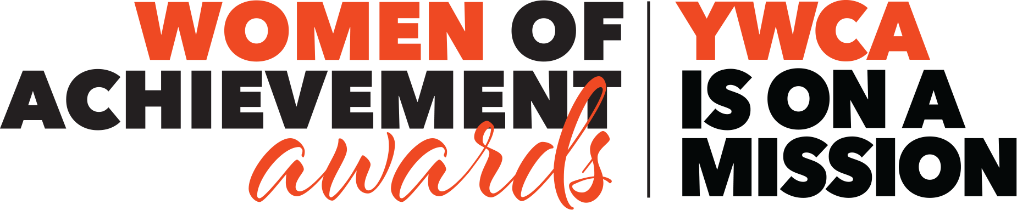

YWCA Lancaster is dedicated to eliminating racism, empowering women, and promoting peace, justice, freedom, and dignity for all!
We are proud to celebrate six years of showcasing the accomplishments of women, who, through their careers and volunteerism, live out our mission in Lancaster County. These women are business leaders, educators, medical professionals, public servants, artists, volunteers, and more who serve as mentors and role models in the community.
This is your opportunity to recognize their accomplishments and contributions by nominating them for the 6th Annual Women of Achievement Awards!
Please take a moment to review the following nomination packet and consider who you can nominate.
- We welcome your nomination of multiple Women and Gender Expansive individuals and ask you to alert your candidate(s) of their nomination.
- Nominations must be received by June 3, 2022 by 5:00 PM.
- The selection committee, composed of past Women of Achievement Honorees, will announce the 2022 Honorees in June.
- Join us at the YWCA Women of Achievement Awards on October 20, 2022 from 11:30 AM – 1:00 PM to honor these amazing individuals!

The nomination form and partnership opportunities are available online at ywcalancaster.org/WomenOfAchievement. Event details and registration will be available in
August.

We thank you in advance for helping us pay tribute to the women and gender expansive leaders in our community!

Kindest Regards,
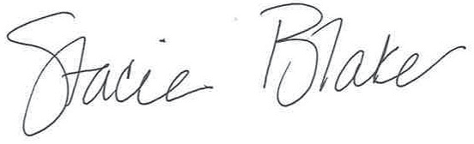
STACIE BLAKE
Chief Executive Officer
YWCA Lancaster

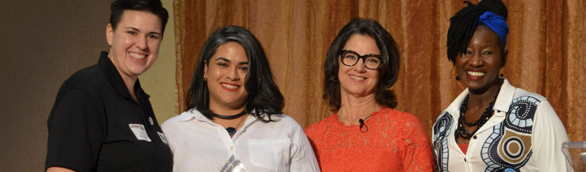

WOMEN OF ACHIEVEMENT HONOREES
These women—honored as Women of Achievement—come from a wide variety of backgrounds and experiences. But each share a deep commitment to breaking down barriers and creating opportunities for women in Lancaster County. Today, many are still actively doing just that: acting as leaders in their workplaces and communities.

2017
KATHLENE SULLIVAN, Social Media Director
Lancaster City Alliance
JEANNIE SADAPHAL, Director of Membership Development
Discover Lancaster
FARIHA SARIJ, MD
Hospice and Community Care Lancaster
SUSAN LANDES, Executive Director
Lancaster Recreation Commission
HENRIETTA HEISLER, President
HH Interiors, Inc
JESSICA KING, Chief of Staff
City of Lancaster

2018
MELISA BAEZ, Director of Entrepreneur Training,
ASSETS
VY BANH, Co-owner
Rice and Noodles Restaurant
DR. BETH BECKER, Grade 9 Principal
Hempfield School District
BONNIE GLOVER, Retired Director
Domestic Violence Services of Lancaster
WILLONDA MCCLOUD, President & CEO
Bright Side Opportunities Center
KAYLA SCHNEIDER
Child Advocate and Miss Keystone 2018

2019
TIMBREL CHYATEE ADIDALA, Founder CHYATEE
Creative Director, The Cultured Workshop
MILZY CARRASCO, Director of Neighborhood Engagement
City of Lancaster, PA
ALESHA R. MARTIN, Owner TurnN/Headz Hair Studio, Lancaster and Founder of Breathe Again, The Sheena Martin Foundation
FRAN RODRIGUEZ, Senior Program Officer
Lancaster County Community Foundation
KESHA MORANT WILLIAMS, PH.D., Associate
Professor of Communication Arts & Sciences
Penn State Berks
KATE ZIMMERMAN, Executive Director
Leadership Lancaster

2020
DORCAS CYSTER, BSN, RN, Supervisor
Penn Medicine Lancaster General Health
EVITA COLON, Founder
Speak to My Soul
K FOLEY, Executive Director
Lancaster LGBTQ+ Coalition
VANESSA PHILBERT, Chief Executive Officer
Community Action Partnership

2021
STARLEISHA MICHELLE GINGRICH, Executive
Director
Penn Medicine Lancaster General Health
DR. CHERISE HAMBLIN OB/GYN, Pennn Medicine Lancaster General Health; Founder & President Patients R Waiting
Penn Medicine Lancaster General Health, Patients R Waiting
NORMA VAZQUEZ, Certified Lactation Counselor, Founder and Birth & Postpartum Doula, Mama La Lechera
Penn Medicine Lancaster General Health, Mama La Lechera
SOBEIDA ROSA, Communications & Development Manager, Touchstone Foundation; Co-Founder, Lancaster Changemakers
Touchstone Foundation, Lancaster Changemakers

2022 WOMEN OF ACHIEVEMENT NOMINATION FORM

Nominator(s) Information
First Name Last Name Email Phone Number Mailing Address City State Zip

If applicable:
Title Company or Organization Company or Organization Address City State Zip Your relationship to the Nominee

I certify that:
I am not an immediate family member of the nominee. This personis not my parent, child, or partner. The person I want to nominate is not a YWCA staff member, current board member, or Women of Achievement committee member.
The person I want to nominate is not seeking an elected office.
The person I want to nominate lives, works, or volunteers in Lancaster County.

Please provide your nominee’s contact information below:
First Name Last Name Email Phone Number Mailing Address City State Zip

If applicable:
Title Company or Organization Company or Organization Address City State Zip Age Range: 16 – 25 26+

Choose a category that best applies to the nominee:
Arts & Education Business
Civic & Nonprofit Health & Wellness
Cheryl Gahring Young Woman of Achievement (16-25 years old)

Is the nominee aware that you are nominating them? Yes No

Please provide the following information for your nominee. Please type your response. The information provided will be used when selecting honorees so please include detail and dates where applicable. Suggested length of answers is 150 - 300 words per question.

- Describe how your nominee excels in their profession/occupation/volunteerism that distinguishes the nominee as a Woman of Achievement.

- Describe the work your nominee has done towards eliminating racism, empowering women or promoting peace, justice, freedom and dignity for all in the workplace and/or community.

- Through their mentoring efforts, provide an example of how they have transformed someone’s life.

Nomination submissions must be received by 5 PM EST on June 3, 2022. No exceptions will be made. They must be submitted via the (1) Online form (2) Downloadable, fillable PDF form emailed epatota@ywcalancaster.org or (3) Printed copy mailed to YWCA Lancaster, 110 North Lime Street, Lancaster, PA 17602.
All information submitted will remain confidential and will be used exclusively for the purpose of the YWCA Lancaster Women of Achievement Awards.
Questions? Contact Erin Patota at erin@ywcalancaster.org or 410.292.8831.

